Dillon School District Four
Honors Teachers
at
Teacher of the Year Banquet

Ali Rogers Huggins, first grade teacher at East Elementary School, was named the 2018-2019 Teacher of the Year at the annual banquet held on Monday, October 15, 2018. Mrs. Huggins and seven colleagues representing their schools attended the banquet with district administrators, board members, and special guests.

The annual banquet was held in the foyer of the auditorium located at 1738 Highway 301 North. After a delicious dinner was served, principals introduced school representatives and shared attributes that contributed to their selection for this honor.

Each 2018-2019 Teacher of the Year school representative received an engraved gift from the Board of Trustees. Superintendent, D. Ray Rogers, and board chair, Ethel Taylor, made presentations and expressed their gratitude to each teacher. After school administrators recognized their representatives and board presentations were made, Horace Mann insurance agent, David Stanley, recognized each recipient with a monetary award and thanked them for their service.

Dillon School District Four Superintendent, D. Ray Rogers, shared his admiration and appreciation to all candidates before announcing the district winner. As the district’s 2018-2019 District Teacher of the Year, Mrs. Huggins received a monetary award and an engraved watch denoting this special honor.

As the district’s representative, Mrs. Huggins will be invited to attend professional development trainings especially designed for district honorees and she will participate in the 2020 State Teacher of the Year competition. Her application will be submitted to the South Carolina Department of Education for inclusion. On May 8, 2019, Mrs. Huggins will be invited to attend the Teacher of the Year Celebration in Columbia. During the gala, State Superintendent of Education, Molly Spearman, will announce the 2020 State Teacher of the Year.

School representatives recognized with Mrs. Huggins included: Victoria Gray, teacher at South Elementary, Sandy Stephens, teacher at Stewart Heights Elementary, Shirbey Johnson, teacher at Lake View Elementary, Brooke Wright, teacher at Gordon Elementary, Jacqueline Smith, teacher at Dillon Middle School, Maurice Robinson, teacher at Dillon High School, and Samanthia Evans, teacher at Lake View High School.

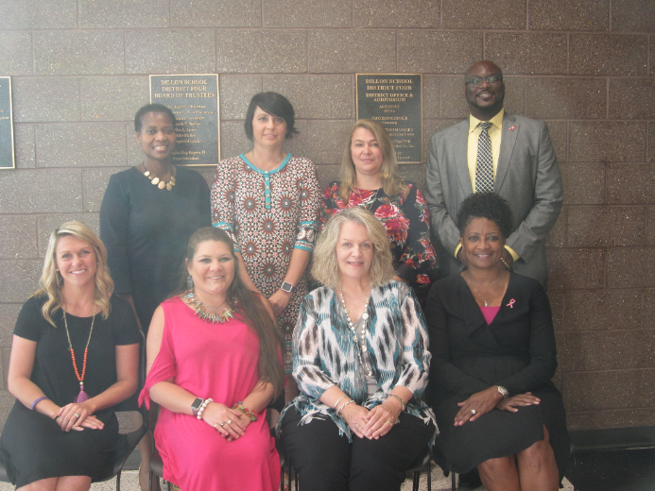

Pictured: (Left to Right)

- Seated- Ali Huggins, Victoria Gray, Sandy Stephens, Shirbey Johnson
- Standing- Jacqueline Smith, Brooke Wright, Samanthia Evans, Maurice Robinson

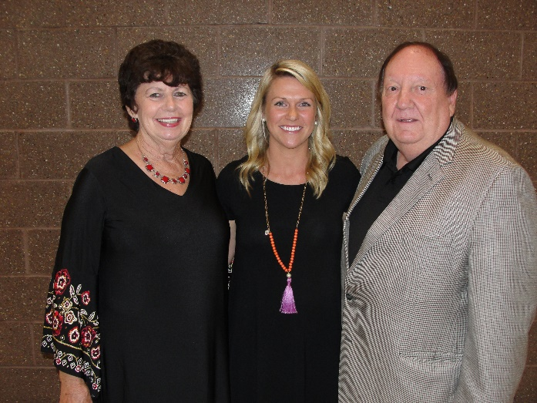

Pictured: (Left to Right)

- Ethel Taylor, Board Chair, Ali Huggins, 2018-2019 District Teacher of the Year, and Ray Rogers, Superintendent

