Gifted and Talented Chorus at Dillon High School Receives
Hootie & the Blowfish Grant

The Dillon High School Gifted and Talented Honors Chorus was pleased and excited to receive a $30,000.00 grant from the Hootie & the Blowfish Foundation. The grant award will be dispersed over a three year period. Kathy Smith, chorus instructor, applied for the grant in the spring of 2018. The title chosen for the grant proposal was Stayin’ the Chorus. The planned outcome of the project was to inspire the GT artistic students to stay in the chorus during their high school years, which would in turn give them time to strengthen their talents and expand their knowledge of the music industry.
Darius Rucker and his bandmates, support the arts in the state of South Carolina by annually identifying music programs that directly impact students and local communities. Over the course of Dillon High School’s grant period, students identified as gifted and talented in chorus will have the opportunity to visit colleges and music venues, meet artists in the entertainment field, participate in scholarship activities and choral workshops, and perform in their home community.
Kathy Smith, chorus instructor, will use funds to purchase choir robes, travel wear, music, stands, folders, and sound equipment to expand her program. Funds will also be used to allow the students to perform in the Christmas parade each year. This type of community exposure will bring pleasure to family, friends, and local community members, while providing the students with an outlet for their giftedness.
With resources made available through the grant, the hope is that the students will continue to expand their talents and maintain a personal interest in the field of music and entertainment. Who knows, by helping the students Stayin’ the Chorus, Dillon County may have another hometown kid, just like Darius Rucker, to “make it big” in the music industry.
A heartfelt thanks goes out to the Hootie & the Blowfish Foundation and the Central Carolina Community Foundation, under the direction of Erin E. Johnson, VP for Community Investment, for supporting the GT Honors Chorus Program at Dillon High School. Through the grant award at Dillon High School and others across the state, Hootie & the Blowfish band members are personally touching the hearts, minds, and lives of children in South Carolina, as well as, local communities.

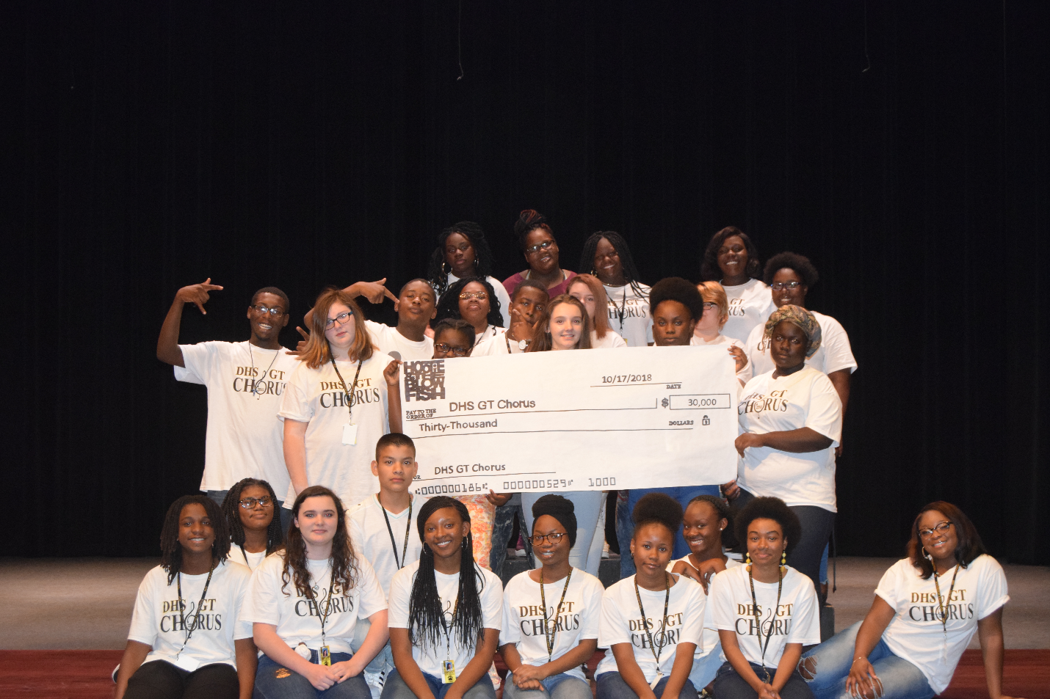

Pictured: (Left to Right)
Seated: Kannaji Peppers, Sinaayah Mathis, Caroline Williams, Brallam Gomez, Jada Reaves, Emeline Niyibitanga, Shania Brown, Jala Lewis, Jade McDowell, and Dy’Shania McMillan.

Standing:
1st Row: Deaundre James, Haley Gendreau, Dukunde Marie-Paredes, Imirah Walters, Annette Habonimana, and Anne Ndayishimiye,
2nd Row: Deonte Godfrey, Malaysia Davis, James McLellan, Destiny Ward, Saheed Bethea, India Lockemy, Ava Lewis
3rd Row: Ja’Nayshia Rowell, Mariann Thompson, Tiniya Gilchrist, Zaria Johnson

(Not Pictured)
Akayla Samuel, Shanise Brown

