Student Recognized for 2018 SC READY Perfect Score
At the October 15, 2018 Dillon School District Four Board of Trustees meeting, Aristide Nizeyimana, ninth grade student at Dillon High School, was recognized for having a perfect score on his 2018 SC READY state assessment. Aristide received a perfect score on the math portion of his eighth grade test that was administered last May. Superintendent, D. Ray Rogers, and board chairman, Ethel Taylor, congratulated Aristide for a job well-done. Aristide and his mother, Christine Mpawenimana, attended the recognition ceremony which took place at the beginning of the regularly scheduled board meeting. Aristide received a certificate denoting this special accomplishment and a book bag filled with school supplies. During the presentation, Aristide was also complimented for his eligibility in the gifted and talented program and recognition was given to Aristide’s eighth grade math teacher, Melinda Brown. In closing, Mr. Rogers encouraged Aristide to continue his academic excellence.
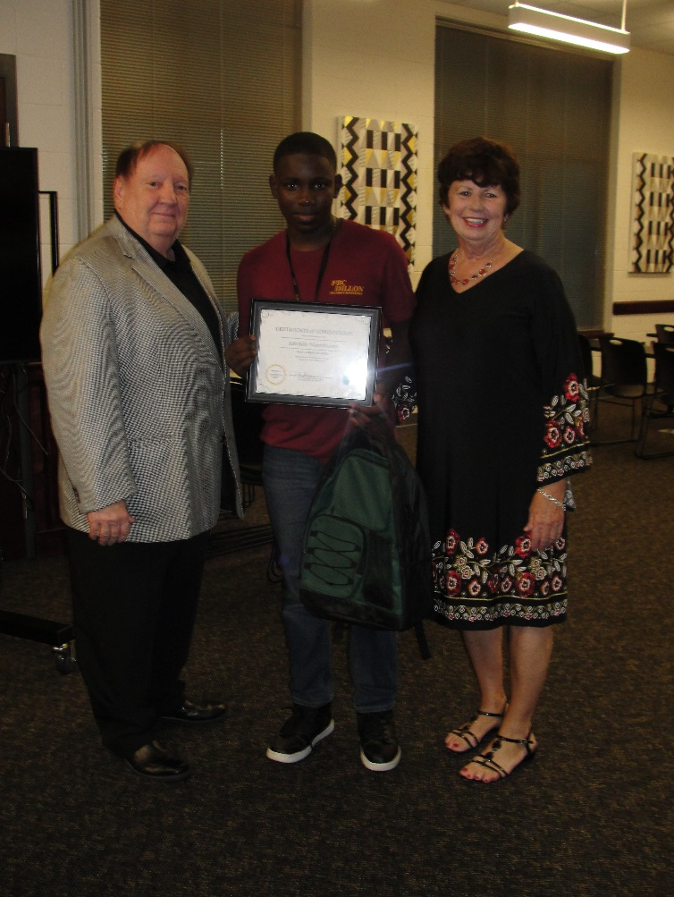

Pictured: (Left to Right)
Ray Rogers, Superintendent, Aristide Nizeyimana, and Ethel Taylor, Board Chairman

