Perfect SCPASS Score
At the November 21, 2016 Dillon School District Four Board of Trustees meeting, Deanna McCrimmon, student at Gordon Elementary, was recognized for having a perfect score on her SCPASS state assessment. Deanna received a perfect score on the science portion of her fourth grade SCPASS test that was administered last May. Superintendent, Ray Rogers, and Board Chairman, Ethel Taylor, congratulated Deanna for a job well-done. Deanna’s principal, Famon Whitfield III, her mother, Sarah McCrimmon, and her sister, Breana McCrimmon, attended the recognition ceremony which took place at the beginning of the regularly scheduled board meeting. Deanna received a certificate denoting this special accomplishment and a book bag filled with school supplies. During the presentation, the teachers Deanna has had during her school career in Dillon School District Four were named. Collectively, along with her family, they have played an important role in her successful school career. Her previous teachers include: 4K- Paulette Rogers, 5K- Suzanne McLaurin, 1st Grade- Sandy Stephens, 2nd Grade- Holli Strickland, 3rd Grade- Gina Page, and 4th Grade- Christen Bucy. In closing, Mr. Rogers encouraged Deanna to continue her education and that he looked forward to recognizing her in the future for her outstanding academic accomplishments.
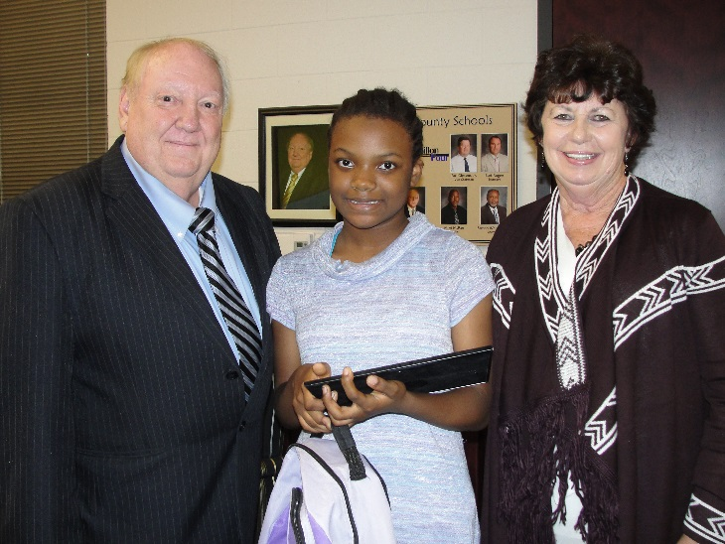

Pictured: (Left to Right)
Ray Rogers, Superintendent, Deanna McCrimmon, and Ethel Taylor, Board Chairman.

