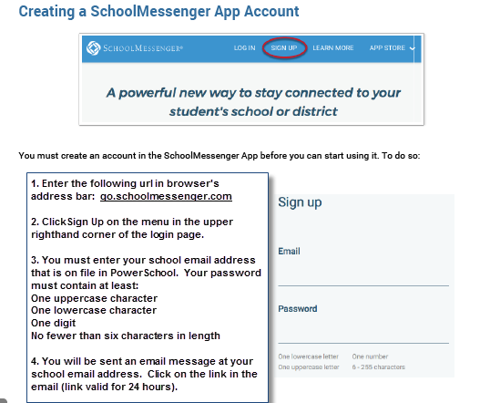
Creating a SchoolMessenger Account

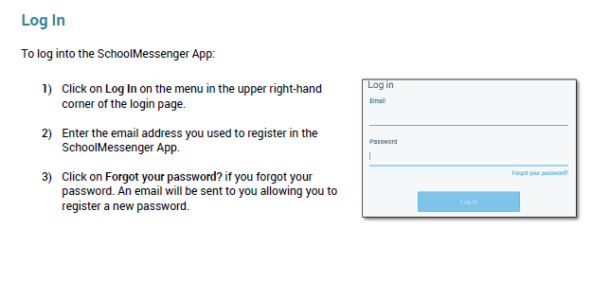

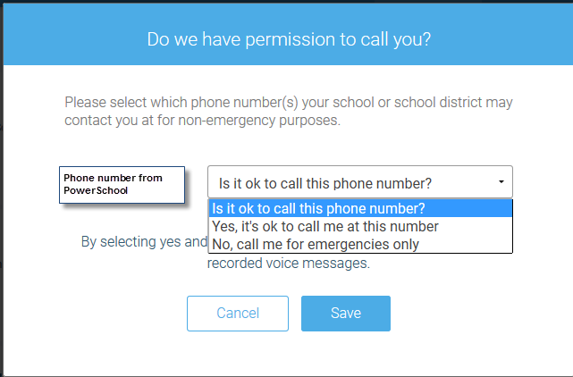
When you first sign into SchoolMessenger, you will receive the following prompt for the phone numbers in PowerSchool.

The phone number is associated with the guardian record. The guardian will still be notified even if No is selected.

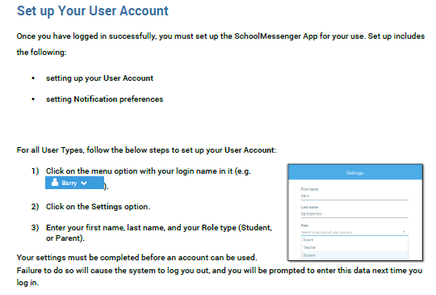

Note: Students select the Student Role type – only the student’s school email will be included and students cannot edit or add a phone number.

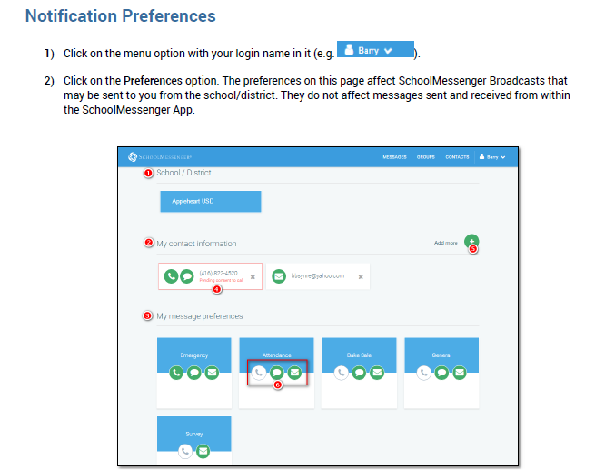

Responding to a SchoolMessenger Message

